|  |  |  |  |  |  |  |  |  |  |  |  |  |  |  |  |  |  |  |  |  |  |  |  |  |  |  |  |  |  |  |  |  |
| --- | --- | --- | --- | --- | --- | --- | --- | --- | --- | --- | --- | --- | --- | --- | --- | --- | --- | --- | --- | --- | --- | --- | --- | --- | --- | --- | --- | --- | --- | --- | --- | --- |
| 1. REKAPITULASI INDIKATOR PENILAIAN PENGHARGAAN PEMBAURAN KEBANGSAAN UNTUK PERORANGAN | | | | | | | | | | | | | | | | | | | | | | | | | | | | | | | | |
| NASIONAL | | | | | | | | | | | PROVINSI | | | | | | | | | KABUPATEN/KOTA | | | | | | | | | | | | |
|  | INDIKATOR PENILAIAN | | | | | | | | | | | | | | | | | | | | | | | | | | | | | | | |
| 1 | Faktor Umum | | | | | | | NILAI | | | Faktor Umum | | | | | | | NILAI | | Faktor Umum | | | | | | | | NILAI | | | | |
|  | a) | Bentuk Dukungan | | | |  | | |  | | | a) | Bentuk Dukungan | | | |  | |  | a) | Bentuk Dukungan | | | | | |  | | |  | | |
|  |  | a. | | Partisipan | | 3 | | | skor | | |  | a. | | partisipan | | 3 | | skor |  | a. | | partisipan | | | | 3 | | | skor | | |
|  |  | b. | | mediator | | 6 | | | skor | | |  | b. | | mediator | | 6 | | skor |  | b. | | mediator | | | | 6 | | | skor | | |
|  |  | c. | | fasilitator | | 10 | | | skor | | |  | c. | | fasilitator | | 10 | | skor |  | c. | | fasilitator | | | | 10 | | | skor | | |
|  | b) | Luas Cakupan | | | |  | | |  | | | b) | Luas Cakupan | | | |  | |  | b) | Luas Cakupan | | | | | |  | | |  | | |
|  |  | a. | | Kabupaten/kota | | 3 | | | skor | | |  | a. | | kecamatan | | 3 | | skor |  | a. | | desa/kelurahan | | | | 3 | | | skor | | |
|  |  | b. | | provinsi | | 6 | | | skor | | |  | b. | | kabupaten/kota | | 6 | | skor |  | b. | | kecamatan | | | | 6 | | | skor | | |
|  |  | c. | | nasional | | 10 | | | skor | | |  | c. | | provinsi | | 10 | | skor |  | c. | | Kebupaten/kota | | | | 10 | | | skor | | |
|  | c) | Jumlah peran serta | | | |  | | |  | | | c) | Jumlah peran serta | | | |  | |  | c) | Jumlah peran serta | | | | | |  | | |  | | |
|  |  | a. | | dua kegiatan pembauran | | 3 | | | skor | | |  | a. | | dua kegiatan pembauran | | 3 | | skor |  | a. | | dua kegiatan pembauran | | | | 3 | | | skor | | |
|  |  | b. | | tiga kegiatan pembauran | | 6 | | | skor | | |  | b. | | tiga kegiatan pembauran | | 6 | | skor |  | b. | | tiga kegiatan pembauran | | | | 6 | | | skor | | |
|  |  | c. | | lima kegiatan pembauran | | 10 | | | skor | | |  | c. | | lima kegiatan pembauran | | 10 | | skor |  | c. | | lima kegiatan pembauran | | | | 10 | | | skor | | |
|  | d) | Dukungan Dana | | | |  | | |  | | | d) | Dukungan Dana | | | |  | |  | d) | Dukungan Dana | | | | |  | | | | |  | |
|  |  | a. | | pihak ketiga | | 3 | | | skor | | |  | a. | | pihak ketiga | | 3 | | skor |  | a. | | | pihak ketiga | | 3 | | | | | skor | |
|  |  | b. | | sumbangan suka rela | | 6 | | | skor | | |  | b. | | sumbangan suka rela | | 6 | | skor |  | b. | | sumbangan suka rela | | | | 6 | | | skor | | |
|  |  | c. | | pribadi | | 10 | | | skor | | |  | c. | | pribadi | | 10 skor | | |  | c. | | pribadi | | | | 10 | | | skor | | |
|  |  | |  | |  | | 40 | | | skor | |  | |  | | 40 skor | | | |  | |  | | |  | | | | 40 | | | skor |

|  |  |  |  |  |  |  |  |  |  |  |  |  |  |  |  |  |  |  |  |  |  |  |  |  |  |  |  |  |  |  |  |
| --- | --- | --- | --- | --- | --- | --- | --- | --- | --- | --- | --- | --- | --- | --- | --- | --- | --- | --- | --- | --- | --- | --- | --- | --- | --- | --- | --- | --- | --- | --- | --- |
| 2 | Faktor Teknis | | | | NILAI | | | |  | | | | | | NILAI | | | | | |  | | |  | | | | NILAI | | | |
|  | a) | Jumlah kegiatan pembauran kebangsaan dibidang bahasa | | |  |  | | | a) | | Jumlah kegiatan pembauran kebangsaan dibidang bahasa dan/atau adat istiadat | | | | | |  | |  | | a) | | Jumlah kegiatan pembauran kebangsaan dibidang bahasa dan/atau adat istiadat | | | | | |  |  | |
|  |  | < 2 | Penguasaan bahasa | | 3 | skor | | |  | | < 2 | Penguasaan bahasa dan/atau pengintegrasian | | | | | 3 | | skor | |  | | < 2 | | penguasaan bahasa dan/atau pengintegrasian | | | | 3 | skor | |
|  |  | 3-4 | Penguasaan bahasa | | 6 | skor | | |  | | 3.-.4 | Penguasaan bahasa dan/atau pengintegrasian | | | | | 6 | | skor | |  | | 3-4 | | penguasaan bahasa dan/atau pengintegrasian | | | | 6 | skor | |
|  |  | >5 | Penguasaan bahasa | | 10 | skor | | |  | | >5 | Penguasaan bahasa dan/atau pengintegrasian | | | | | 10 | | skor | |  | | >5 | | penguasaan bahasa dan/atau pengintegrasian | | | | 10 | skor | |
|  | b) | Jumlah kegiatan pembauran kebangsaan dibidang adat istiadat | | |  |  | | | b) | | Jumlah kegiatan pembauran pembauran kebangsaan dibidang seni budaya dan/atau pendidikan | | | | | |  | |  | | b) | | Jumlah kegiatan pembauran kebangsaan dibidang seni budaya dan/atau pendidikan dan/atau perekonomian | | | | | |  |  | |
|  |  | < 2 | Pengintegrasian | | 3 | skor | | |  | | < 2 | Penyatuan seni budaya dan/atau program | | | | | 3 | | skor | |  | | < 2 | | penyatuan seni budaya dan/atau program dan/atau mediasi | | | | 3 | skor | |
|  |  | 3-4 | Pengintegrasian | | 6 | skor | | |  | | 3.-.4 | Penyatuan seni budaya dan/atau program | | | | | 6 | | skor | |  | | 3-4 | | penyatuan seni budayaan/atau program dan/atau mediasi | | | | 6 | skor | |
|  |  | >5 | Pengintegrasian | | 10 | skor | |  | | >5 | | | Penyatuan seni budaya dan/atau program | | | 10 | | skor | |  | | >5 | | | | penyatuan seni budaya dan/atau program dan/atau mediasi | 10 skor | | | |
|  | c) | Jumlah kegiatan pembauran kebangsaan dibidang seni budaya | | |  |  | | | c) | | Jumlah kegiatan pembauran pembauran kebangsaan dibidang perekonomian | | | | | |  | |  | |  | |  | | | | | |  |  | |
|  |  | < 2 | Penyatuan seni budaya | | 3 | skor | | |  | | < 2 | Mediasi pembauran kebangsaan | | | | | 3 | | skor | |  | |  | |  | | | |  |  | |
|  |  | 3-4 | Penyatuan seni budaya | | 6 | skor | | |  | | 3.-.4 | Mediasi pembauran kebangsaan | | | | | 6 | | skor | |  | |  | |  | | | |  |  | |
|  |  | >5 | Penyatuan seni budaya | | 10 | skor | | |  | | >5 | Mediasi pembauran kebangsaan | | | | | 10 | | skor | |  | |  | |  | | | |  |  | |
|  | d) | Jumlah kegiatan pembauran kebangsaan dibidang pendidikan | | |  |  | | |  | |  | | | | | |  | |  | |  | |  | | | | | |  |  | |
|  |  | < 2 | program | | 3 | skor | | |  | |  |  | | | | |  | |  | |  | |  | |  | | | |  |  | |
|  |  | 3-4 | program | | 6 | skor | | |  | |  |  | | | | |  | |  | |  | |  | |  | | | |  |  | |
|  |  | >5 | program | | 10 | skor | | |  | |  |  | | | | |  | |  | |  | |  | |  | | | |  |  | |
|  | e) | Jumlah kegiatan pembauran kebangsaan dibidang perekonomian | | |  |  | | |  | |  | | | | | |  | |  | |  | |  | | | | | |  |  | |
|  |  | < 2 | Mediasi pembauran perekonomian | | 3 | skor | | |  | |  |  | | | | |  | |  | |  | |  | |  | | | |  |  | |
|  |  | 3-4 | Mediasi pembauran perekonomian | | 6 | skor | | |  | |  |  | | | | |  | |  | |  | |  | |  | | | |  |  | |
|  |  | >5 | Mediasi pembauran perekonomian | | 10 | skor | | |  | |  |  | | | | |  | |  | |  | |  | |  | | | |  |  | |
|  |  |  | 50 skor | | | | | |  | |  |  | | | | | 30 skor | | | |  | |  | |  | | | | 20 | Skor | |
| CARA PENILAIAN | | | | | | | | | | | | | | | | | | | | | | | | | | | | | | | |
| Faktor Umum + Teknis | | | | | 90 | skor |  | | | | | | | | | | 70 | | skor | |  | | | | | | | | 60 | Skor | |
| PERINGKAT PENERIMA | | | | NILAI | | | | |  | | | | | NILAI | | | | | | | NILAI | | | | | | | | | |
|  | Peringkat | | I | | 80 – 90 | | | |  | |  |  | | | | | 60 – 70 | | | |  | |  | |  | | | | 50 – 60 | | |
|  | Peringkat | | II | | 70 – 79 | | | |  | |  |  | | | | | 50 – 59 | | | |  | |  | |  | | | | 40 – 49 | | |
|  | Peringkat | | III | | 60 - 69 | | | |  | |  |  | | | | | 40 - 49 | | | |  | |  | |  | | | | 30 - 39 | | |

|  |  |  |  |  |  |  |  |  |  |  |  |  |  |  |  |  |  |  |  |  |  |  |  |  |  |  |  |  |  |  |  |
| --- | --- | --- | --- | --- | --- | --- | --- | --- | --- | --- | --- | --- | --- | --- | --- | --- | --- | --- | --- | --- | --- | --- | --- | --- | --- | --- | --- | --- | --- | --- | --- |
| 1. REKAPITULASI INDIKATOR PENILAIAN PENGHARGAAN PEMBAURAN KEBANGSAAN UNTUK ORGANISASI KEMASYARAKATAN/LNL | | | | | | | | | | | | | | | | | | | | | | | | | | | | | | | |
| NASIONAL | | | | | | | | | | | PROVINSI | | | | | | | | | | | KABUPATEN/KOTA | | | | | | | | | |
| A | | INDIKATOR PENILAIAN | | | | | | | | | | | | | | | | | | | | | | | | | | | | | |
| 1 | Faktor Umum | | | | | NILAI | | | | |  | | |  | | NILAI | | | | |  | | | | | | NILAI | | | | |
|  | a) | | Status organisasi/LNL | | |  | |  | | | a) | Status organisasi/LNL | | | |  | |  | | | a) | | Status organisasi/LNL | | | |  | |  | | |
|  |  | | a. | status organisasi/LNL | | 2 | | skor | | |  | a. | | status organisasi/LNL | | 2 | | skor | | |  | | a. | | status organisasi/LNL | | 2 | | Skor | | |
|  |  | | b. | proses pendaftaran | | 5 | | skor | | |  | b. | | proses pendaftaran | | 5 | | skor | | |  | | b. | | proses pendaftaran | | 5 | | Skor | | |
|  |  | | c. | jelas | | 8 | | skor | | |  | c. | | jelas | | 8 | | skor | | |  | | c. | | jelas | | 8 | | Skor | | |
|  | b) | | Visi dan misi | | |  | |  | | | b) | Visi dan misi | | | |  | |  | | | b) | | Visi dan misi | | | |  | |  | | |
|  |  | | a. | belum ada | | 2 | | skor | | |  | a. | | belum ada | | 2 | | skor | | |  | | a. | | belum ada | | 2 | | Skor | | |
|  |  | | b. | meragukan | | 5 | | skor | | |  | b. | | meragukan | | 5 | | skor | | |  | | b. | | meragukan | | 5 | | skor | | |
|  |  | | c. | nasional | | 8 | | skor | | |  | c. | | nasional | | 8 | | skor | | |  | | c. | | nasional | | 8 | | skor | | |
|  |  | |  |  | |  | |  | | |  |  | |  | |  | |  | | |  | |  | |  | |  | |  | | |
|  | c) | | Azas organisasi | | |  | |  | | | c) | Azas organisasi | | | |  | |  | | | c) | | Azas organisasi | | | |  | |  | | |
|  |  | | a. | tidak ada | | 2 | | skor | | |  | a. | | tidak ada | | 2 | | skor | | |  | | a. | | Tidak ada | | 2 | | skor | | |
|  |  | | b. | tidak sesuai | | 5 | | skor | | |  | b. | | tidak sesuai | | 5 | | skor | | |  | | b. | | Tidak sesuai | | 5 | | skor | | |
|  |  | | c. | sesuai | | 8 | | skor | | |  | c. | | sesuai | | 8 | | skor | | |  | | c. | | sesuai | | 8 | | skor | | |
|  |  | |  |  | |  | |  | | |  |  | |  | |  | |  | | |  | |  | |  | |  | |  | | |
|  | d) | | AD/ART dan bantuan dana | | |  | |  | | | d) | AD/ART dan bantuan dana | | | |  | |  | | | d) | | AD/ART dan bantuan dana | | | |  | |  | | |
|  |  | | a. | tidak ada | | 2 | | skor | | |  | a. | | tidak ada | | 2 | | skor | | |  | | a. | | tidak ada | | 2 | | skor | | |
|  |  | | b. | ada dan terbatas | | 5 | | skor | | |  | b. | | ada dan terbatas | | 5 | | skor | | |  | | b. | | ada dan terbatas | | 5 | | skor | | |
|  |  | | c. | ada dan memuaskan | | 8 | | skor | | |  | c. | | ada dan memuaskan | | 8 | | skor | | |  | | c. | | ada dan memuaskan | | 8 | | skor | | |
|  |  | |  |  | |  | |  | | |  |  | |  | |  | |  | | |  | |  | |  | |  | |  | | |
|  | e) | | Wilayah kerja | | |  | |  | | | e) | Wilayah kerja | | | |  | |  | | | e) | | Wilayah kerja | | | |  | |  | | |
|  |  | | a. | kabupaten/kota | | 2 | | skor | | |  | a. | | kecamatan | | 2 | | skor | | |  | | a. | | desa/kelurahan | | 2 | | skor | | |
|  |  | | b. | provinsi | | 5 | | skor | | |  | b. | | kabupaten/kota | | 5 | | skor | | |  | | b. | | kecamatan | | 5 | | skor | | |
|  |  | | c. | nasional | | 8 | | skor | | |  | c. | | provinsi | | 8 | | skor | | |  | | c. | | kabupaten/kota | | 8 | | skor | | |
|  |  | |  |  | |  | |  | | |  |  | |  | |  | |  | | |  | |  | |  | |  | |  | | |
|  |  | |  |  | | 40 | | skor | | |  |  | |  | | 40 | | skor | | |  | |  | |  | | 40 | | skor | | |
| 2 | faktor teknis | | | | | NILAI | | | | |  | | |  | | NILAI | | | | |  | | | |  | | NILAI | | | | |
|  | a) | | Jumlah penyelenggaraan program pembauran kebangsaan dibidang bahasa dalam setahun | | |  | |  | | | a) | Jumlah penyelenggara program pembauran kebangsaan dibidang bahasa dan/atau adat istiadat dalam setahun | | | |  | |  | | | a) | | Jumlah penyelenggaraan program pembauran kebangsaan dibidang bahasa dan /atau adat istiadat dalam setahun | | | |  | |  | | |
|  |  | | < 2 | Program | | 3 | | skor | | |  | < 2 | | Program | | 3 | | skor | | |  | | < 2 | | program | | 3 | | skor | | |
|  |  | | 3.-.4 | Program | | 6 | | skor | | |  | 3.-.4 | | Program | | 6 | | skor | | |  | | 3.-.4 | | program | | 6 | | skor | | |
|  |  | | >5 | Program | | 10 | | skor | | |  | >5 | | Program | | 10 | | skor | | |  | | >5 | | program | | 10 | | skor | | |
|  | b) | | Jumlah penyelenggaraan program pembauran kebangsaan dibidang adat istiadat dalam setahun | | |  | |  | | | b) | Jumlah penyelenggara program pembauran kebangsaan dibidang seni budaya dan/atau pendidikan dalam setahun | | | |  | |  | | | b) | | Jumlah penyelenggaraan program pembauran kebangsaan dibidang seni budaya dan/atau pendidikan dan/atau perekonomian dalam setahun | | | |  | |  | | |
|  |  | | < 2 | program | | 3 | | skor | | |  | < 2 | | Program | | 3 | | skor | | |  | | < 2 | | program | | 3 | | skor | | |
|  |  | | 3.-.4 | program | | 6 | | skor | | |  | 3.-.4 | | Program | | 6 | | skor | | |  | | 3.-.4 | | program | | 6 | | skor | | |
|  |  | | >5 | program | | 10 | | skor | | |  | >5 | | Program | | 10 | | skor | | |  | | >5 | | program | | 10 | | skor | | |
|  | c) | | Jumlah penyelenggaraan program pembauran kebangsaan dibidang seni budaya dalam setahun | | |  | |  | | | c) | Jumlah penyelenggara program pembauran kebangsaan dibidang perekonomian dalam setahun | | | |  | |  | | |  | |  | | | |  | |  | | |
|  |  | | < 2 | program | | 3 | | skor | | |  | < 2 | | Program | | 3 | | skor | | |  | |  | |  | |  | |  | | |
|  |  | | 3.-.4 | program | | 6 | | skor | | |  | 3.-.4 | | Program | | 6 | | skor | | |  | |  | |  | |  | |  | | |
|  |  | | >5 | program | | 10 | | skor | | |  | >5 | | Program | | 10 | | skor | | |  | |  | |  | |  | |  | | |
|  | d) | | Jumlah penyelenggaraan program pembauran kebangsaan dibidang pendidikan dalam setahun | | |  | |  | | |  |  | | | |  | |  | | |  | |  | | | |  | |  | | |
|  |  | | < 2 | program | | 3 | | skor | | |  |  | |  | |  | |  | | |  | |  | |  | |  | |  | | |
|  |  | | 3.-.4 | program | | 6 | | skor | | |  |  | |  | |  | |  | | |  | |  | |  | |  | |  | | |
|  |  | | >5 | program | | 10 | | skor | | |  |  | |  | |  | |  | | |  | |  | |  | |  | |  | | |
|  | e) | | Jumlah penyelenggaraan program pembauran kebangsaan dibidang perekonomian dalam setahun | | |  | |  | | |  |  | | | |  | |  | | |  | |  | | | |  | |  | | |
|  |  | | < 2 | program | | 3 | | skor | | |  |  | |  | |  | |  | | |  | |  | |  | |  | |  | | |
|  |  | | 3.-.4 | program | | 6 | | skor | | |  |  | |  | |  | |  | | |  | |  | |  | |  | |  | | |
|  |  | | >5 | program | | 10 | | skor | | |  |  | |  | |  | |  | | |  | |  | |  | |  | |  | | |
|  |  | |  |  | |  | |  | | |  |  | |  | |  | |  | | |  | |  | |  | |  | |  | | |
|  |  | |  |  | | 50 | | skor | | |  |  | |  | | 30 | | skor | | |  | |  | |  | | 20 | | skor | | |
| CARA PENILAIAN | | | | | |  | |  | | |  | | | | |  | |  | | |  | | | | | |  | |  | | |
| Faktor Umum + Teknis | | | | | | 90 | | skor | | |  | | | | | 70 | | skor | | |  | | | | | | 60 | | skor | | |
| PERINGKATPENERIMA | | | | |  | |  | |  |  | | |  | |  | |  | |  |  | | | |  | |  | |  | |  |
|  | Peringkat | | | I | | 80 – 90 | | | | | Peringkat | | | I | | 60 – 70 | | | | | Peringkat | | | | I | | 50 – 60 | | | | |
|  | Peringkat | | | II | | 70 – 79 | | | | | Peringkat | | | II | | 50 – 59 | | | | | Peringkat | | | | II | | 40 – 49 | | | | |
|  | Peringkat | | | III | | 60 - 69 | | | | | Peringkat | | | III | | 40 - 49 | | | | | Peringkat | | | | III | | 1. - 39 | | | | |

|  |  |  |  |  |  |  |  |  |  |  |  |  |  |  |  |  |  |  |  |  |  |  |  |  |  |  |  |  |  |  |  |  |  |  |  |  |  |  |  |  |  |  |  |  |  |  |  |  |  |  |  |  |  |  |
| --- | --- | --- | --- | --- | --- | --- | --- | --- | --- | --- | --- | --- | --- | --- | --- | --- | --- | --- | --- | --- | --- | --- | --- | --- | --- | --- | --- | --- | --- | --- | --- | --- | --- | --- | --- | --- | --- | --- | --- | --- | --- | --- | --- | --- | --- | --- | --- | --- | --- | --- | --- | --- | --- | --- |
| 1. REKAPITULASI PENILAIAN PENGHARGAAN PEMBAURAN KEBANGSAAN UNTUK PENYELENGGARA PEMERINTAH DAERAH | | | | | | | | | | | | | | | | | | | | | | | | | | | | | | | | | | | | | | | | | | | | | | | | | | | | | | |
| NASIONAL | | | | | | | | | | | | | | | | | | PROVINSI | | | | | | | | | | | | | | | | | | KABUPATEN/KOTA | | | | | | | | | | | | | | | | | | |
|  | INDIKATOR PENILAIAN | | | | | | | | | | | | | | | | | | | | | | | | | | | | | | | | | | | | | | | | | | | | | | | | | | | | | |
| 1 | Faktor Umum | | | | | | | | | | | | | | NILAI | | |  | | |  | | | | | |  | | | | | | NILAI | | | |  | |  | | | | | | | | |  | | | | NILAI | | |
|  | a) | | | | | Jumlah penduduk provinsi | | | | | | | | |  | |  | a) | | Jumlah penduduk kabupaten/kota | | | | | | | | | | | | |  | |  | | a) | | Jumlah penduduk desa/kelurahan: | | | | | | | | | | | | |  | | |
|  |  | | | | | a. | | < 1.500.000 jiwa | | | | | | | 3 skor | | |  | | a. | | | | < 50.000 jiwa | | | | | 3 skor | | | | | | | |  | | a. | | | < 1.000 jiwa | | | | | | | | | | 3 skor | | |
|  |  | | | | | b. | | 1.500.001 – 30.000.000 jiwa | | | | | | | 6 skor | | |  | | b. | | | | 50.001 – 1.000.000 jiwa | | | | | 6 skor | | | | | | | |  | | b. | | | 1.001 – 10.000 jiwa | | | | | | | | | | 6 skor | | |
|  |  | | | | | c. | | > 30.000.001 jiwa | | | | | | | 10 skor | | |  | | c. | | | | > 1.000.001 jiwa | | | | | 10 skor | | | | | | | |  | | c. | | | > 10.001 jiwa | | | | | | | | | | 10 skor | | |
|  | b) | | | | | Luas wilayah | | | | | | | | |  | |  | b) | | Luas wilayah | | | | | | | | | | | | |  | |  | | b) | | Luas wilayah | | | | | | | | | | | | |  | | |
|  |  | | | | | a. | | < 10.000 km2 | | | | | | | 3 skor | | |  | | a. | | | < 50 km2 | | | | | | | 3 skor | | | | | | |  | | a. | | | < 5 km2 | | | | | | | | | | 3 skor | | |
|  |  | | | | | b. | | 10.001 – 80.000 km2 | | | | | | | 6 skor | | |  | | b. | | | 51 – 4.000 km2 | | | | | | | 6 skor | | | | | | |  | | b. | | | 6 – 10 km2 | | | | | | | | | | 6 skor | | |
|  |  | | | | | c. | | > 80.001 km2 | | | | | | | 10 skor | | |  | | c. | | | > 4.001 km2 | | | | | | | 10 skor | | | | | | |  | | c. | | | > 11 km2 | | | | | | | | | | 10 skor | | |
|  | c) | | | | | Jumlah kabupaten/kota | | | | | | | | |  | |  | c) | | Jumlah kecamatan | | | | | | | | | | | | |  | |  | | c) | | Jumlah dukuh/kampung/lingkungan | | | | | | | | | | | | |  | | |
|  |  | | | | | a. | | < 6 Kabupaten/kota | | | | | | | 3 | | skor |  | | a. | | | < 10 kecamatan | | | | | | | | | | 3 skor | | | |  | | a. | | | < 10 dukuh/kampung/lingkungan | | | | | | | | | | 3 skor | | |
|  |  | | | | | b. | | 7 – 14 Kabupaten/kota | | | | | | | 6 | | skor |  | | b. | | | 11 – 20 kecamatan | | | | | | | | | | 6 | | skor | |  | | b. | | | 11 – 20 dukuh/kampung/lingkungan | | | | | | | | | | 6 skor | | |
|  |  | | | | | c. | | > 15 Kabupaten/kota | | | | | | | 10 skor | | |  | | c. | | | > 21 kecamatan | | | | | | | | | | 10 skor | | | |  | | c. | | | > 21 dukuh/kampung/lingkungan | | | | | | | | | | 10 skor | | |
|  | d) | | | | | PAD provinsi pertahun | | | | | | | | |  | |  | d) | | PAD provinsi pertahun | | | | | | | | | | | | |  | |  | | d) | | PAD desa/kelurahan pertahun | | | | | | | | | | | | |  | | |
|  |  | | | | | a. | | < 80 milyar | | | | | | | 3 | | skor |  | | a. | | | < 250 juta | | | | | | | | | | 3 | | skor | |  | | a. | | | < 30 juta | | | | | | | | | | 3 skor | | |
|  |  | | | | | b. | | 80 milyar 1 – 6 triliun | | | | | | | 6 | | skor |  | | b. | | | 250 juta 1 – 500 miliar | | | | | | | | | | 6 | | skor | |  | | b. | | | 30 juta 1 – 200 juta | | | | | | | | | | 6 skor | | |
|  |  | | | | | c. | | > 6 triliun 1 | | | | | | | 10 skor | | |  | | c. | | | > 500 miliar 1 | | | | | | | | | | 10 skor | | | |  | | c. | | | > 200 juta 1 | | | | | | | | | | 10 skor | | |
|  |  | |  | | | |  | | | | 40 skor | | | | | | |  | | | |  | | | | | | 40 skor | | | | | | | | |  | | | | | | |  | | | | |  | | | 40 skor | | |
| a) | | Jumlah fasilitasi penyelenggaraan program pembauran kebangsaan dibidang bahasa dalam setahun | | | | | | | | | | |  | | |  | | | a) | Jumlah fasilitasi penyelenggaraan program pembauran kebangsaan dibidang bahasa dan/atau adat istiadat dalam setahun | | | | | | | | | | |  | | |  | | | a) | | | | Jumlah fasilitasi penyelenggaraan program pembauran kebangsaan dibidang bahasa dan/atau adat istiadat dalam setahun | | | | | | | | | | | |  |  | |
|  | | < 2 | | | | | | | fasilitasi | | | | 3 | | | skor | | |  | < 2 | | | | | fasilitasi | | | | | | 3 | | | skor | | |  | | | | < 2 | | | | | fasilitasi | | | | | | | 3 skor | | |
|  | | 3.-.4 | | | | | | | fasilitasi | | | | 6 | | | skor | | |  | 3.-.4 | | | | | fasilitasi | | | | | | 6 | | | skor | | |  | | | | 3.-.4 | | | | | fasilitasi | | | | | | | 6 skor | | |
|  | | >5 | | | | | | | fasilitasi | | | | 10 skor | | | | | |  | >5 | | | | | fasilitasi | | | | | | 10 skor | | | | | |  | | | | >5 | | | | | fasilitasi | | | | | | | 10 skor | | |
| b) | | Jumlah fasilitasi penyelenggaraan program pembauran kebangsaan dibidang adat istiadat dalam setahun | | | | | | | | | | | | | |  | | | b) | Jumlah fasilitasi penyelenggaraan program pembauran kebangsaan dibidang seni budaya dan/atau pendidikan dalam setahun | | | | | | | | | | |  | | |  | | | b) | | | | Jumlah fasilitasi penyelenggaraan program pembauran kebangsaan dibidang seni budaya dan/atau pendidikan dan/atau perekonomian dalam setahun | | | | | | | | | | | |  |  | |
|  | | < 2 | | | | | | | fasilitasi | | | | 3 | | | skor | | |  | < 2 | | | | | fasilitasi | | | | | | 3 | | | skor | | |  | | | | < 2 | | | | fasilitasi | | | | | | | | 3 skor | | |
|  | | 3.-.4 | | | | | | | fasilitasi | | | | 6 | | | skor | | |  | 3.-.4 | | | | | fasilitasi | | | | | | 6 | | | skor | | |  | | | | 3-4 | | | | fasilitasi | | | | | | | | 6 skor | | |
|  | | >5 | | | | | | | fasilitasi | | | | 10 | | | skor | | |  | >5 | | | | | fasilitasi | | | | | | 10 | | | skor | | |  | | | | >5 | | | | fasilitasi | | | | | | | | 10 skor | | |
| c) | | Jumlah fasilitasi penyelenggaraan program pembauran kebangsaan dibidang seni budaya dalam setahun | | | | | | | | | | |  | | |  | | | c) | Jumlah fasilitasi penyelenggaraan program pembauran kebangsaan dibidang perekonomian dalam setahun | | | | | | | | | | |  | | |  | | |  | | | |  | | | | | | | | | | | |  | | |
|  | | < 2 | | | | | | | fasilitasi | | | | 3 | | | skor | | |  | < 2 | | | | | fasilitasi | | | | | | 3 skor | | | | | |  | | | |  | | | |  | | | | | | | |  | | |
|  | | 3.-.4 | | | | | | | fasilitasi | | | | 6 | | | skor | | |  | 3.-.4 | | | | | Fasilitasi | | | | | | 6 skor | | | | | |  | | | |  | | | |  | | | | | | | |  | | |
|  | | >5 | | | | | | | fasilitasi | | | | 10 skor | | | | | |  | >5 | | | | | Fasilitasi | | | | | | 10 skor | | | | | |  | | | |  | | | |  | | | | | | | |  | | |
| d) | | Jumlah fasilitasi penyelenggaraan program pembauran kebangsaan dibidang pendidikan dalam setahun | | | | | | | | | | |  | | |  | | |  |  | | | | | | | | | | |  | | |  | | |  | | | |  | | | | | | | | | | | |  |  | |
|  | | < 2 | | | | | | | fasilitasi | | | | 3 | | | skor | | |  |  | | | | |  | | | | | |  | | |  | | |  | | | |  | | | |  | | | | | | | |  |  | |
|  | | 3.-.4 | | | | | | | fasilitasi | | | | 6 | | | skor | | |  |  | | | | |  | | | | | |  | | |  | | |  | | | |  | | | |  | | | | | | | |  |  | |
|  | | >5 | | | | | | | fasilitasi | | | | 10 skor | | | | | |  |  | | | | |  | | | | | |  | | |  | | |  | | | |  | | | |  | | | | | | | |  |  | |
| e) | | Jumlah fasilitasi penyelenggaraan program pembauran kebangsaan dibidang perekonomian dalam setahun | | | | | | | | | | |  | | |  | | |  |  | | | | | | | | | | |  | | |  | | |  | | | |  | | | | | | | | | | | |  |  | |
|  | | < 2 | | | | | | | fasilitasi | | | | 3 | | | skor | | |  |  | | | | |  | | | | | |  | | |  | | |  | | | |  | | | |  | | | | | | | |  |  | |
|  | | 3.-.4 | | | | | | | fasilitasi | | | | 6 | | | skor | | |  |  | | | | |  | | | | | |  | | |  | | |  | | | |  | | | |  | | | | | | | |  |  | |
|  | | >5 | | | | | | | fasilitasi | | | | 10 skor | | | | | |  |  | | | | |  | | | | | |  | | |  | | |  | | | |  | | | |  | | | | | | | |  |  | |
|  | | | | |  | | | | 40 skor | | | | | | | | | |  |  | | | | | 30 skor | | | | | | | | | | | |  | | | |  | | | |  | | | | | | | | 20 skor | | |
|  | | | | |  | | | |  | | | |  | | |  | | |  |  | | | | |  | | | | | |  | | |  | | |  | | | |  | | | |  | | | | | | | |  |  | |
| CARA PENILAIAN | | | | | | | | | | | | | | |  | |  | |  | | | | | | | | | | | | | | | | | |  |  | | | | |  | | | | | | | | | | | | |  |
| Faktor Umum + Teknis | | | | | | | | | | | | | | | 90 skor | | | | 70 skor | | | | | | | | | | | | | | | | | |  | | | | | | | | | | | | | 60 skor | | | | | |
|  |  | | | | |  | | | |  | | | | |  | |  | |  | |  | | | | | |  | | | | | | | | | |  |  | |  | | | | | | | | | | |  | | | | |
| PERINGKAT PENERIMA | | | | | | | | | | | | | | | | |  | |  | |  | | | | | |  | | | | | | | | | |  |  | |  | | | | | | | | | | |  | | | | |
| I | | | | Peringkat | | | | | | | | I | | 80 – 90 | | | | | Peringkat | | | | | | | I | | | | | | 50 – 60 | | | | | Peringkat | | | | | | | | | | I | | | | | | 50 – 60 | | |
| II | | | | Peringkat | | | | | | | | II | | 70 – 79 | | | | | Peringkat | | | | | | | II | | | | | | 40 – 49 | | | | | Peringkat | | | | | | | | | | II | | | | | | 40 – 49 | | |
| III | | | | Peringkat | | | | | | | | III | | 60 - 69 | | | | | Peringkat | | | | | | | III | | | | | | 30 - 39 | | | | | Peringkat | | | | | | | | | | III | | | | | | 1. - 39 | | |

D. BENTUK PIAGAM PENGHARGAAN PEMBAURAN KEBANGSAAN

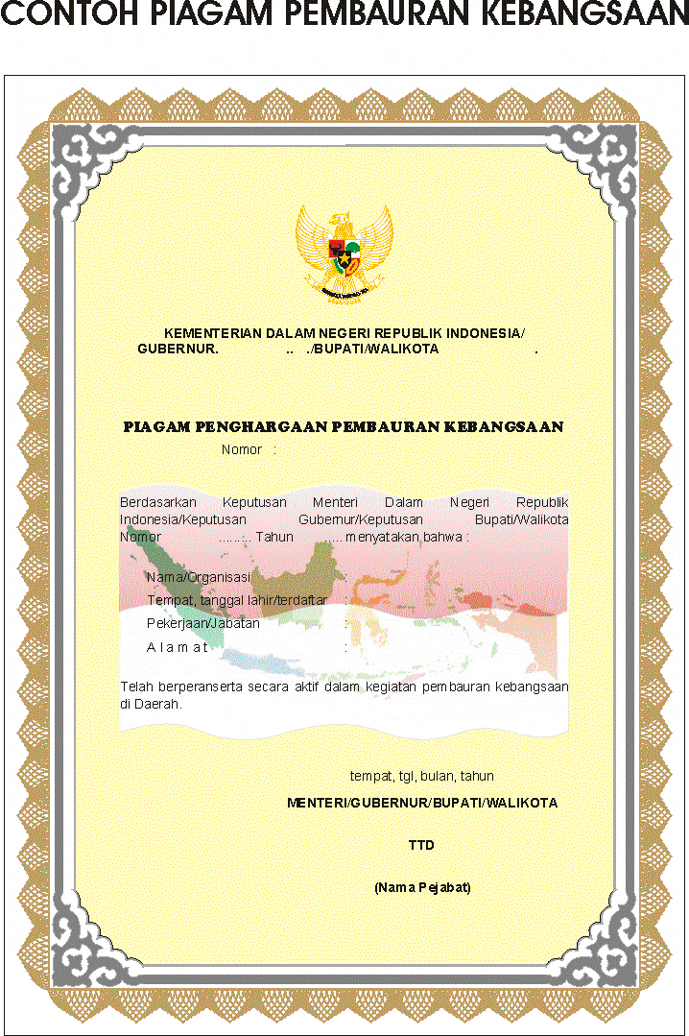

(Gambar garuda kuning keemasan)

KEMENTERIAN DALAM NEGERI REPUBLIK INDONESIA/

KEPUTUSAN GUBERNUR. …………………………………./

KEPUTUSAN BUPATI/WALIKOTA. …………………………

PIAGAM PENGHARGAAN PEMBAURAN KEBANGSAAN

NOMOR :

Berdasarkan Keputusan Menteri Dalam Negeri Republik Indonesia/ Keputusan Gubernur/Keputusan Bupati/Walikota Nomor : ... Tahun …. menyatakan bahwa :

Nama/Organisasi :

Tempat, tanggal lahir/terdaftar :

Pekerjaan/Jabatan :

Alamat :

Telah berperanserta secara aktif dalam kegiatan pembauran kebangsaan di Daerah.

tempat, tgl, bulan, tahun

MENTERI/GUBERNUR/BUPATI/WALIKOTA

TTD

(Nama Pejabat)

E. BENTUK PIALA PENGHARGAAN PEMBAURAN KEBANGSAAN

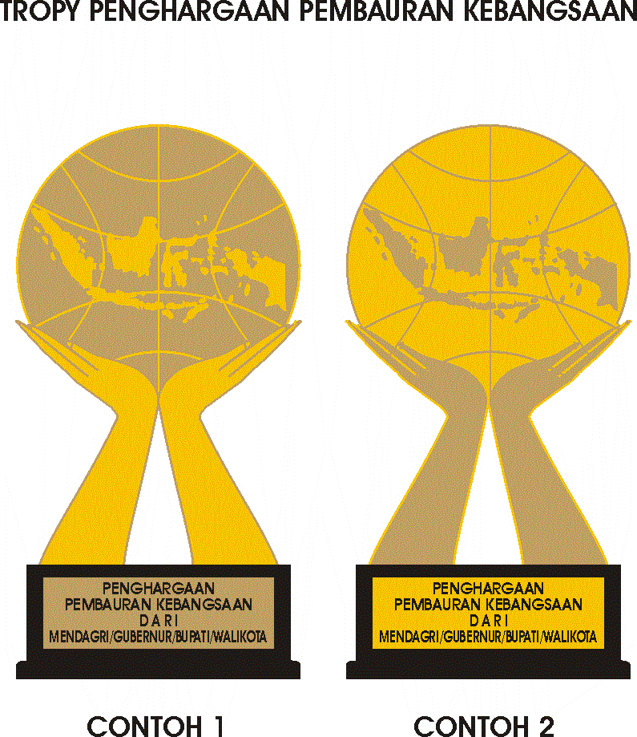

MENTERI DALAM NEGERI

REPUBLIK INDONESIA,

ttd

GAMAWAN FAUZI

Salinan sesuai dengan aslinya

KEPALA BIRO HUKUM

ttd

ZUDAN ARIF FAKRULLOH

Pembina Tk.I (IV/b)

NIP. 19690824 199903 1 001